Weekly sponsor communication

|  |  |
| --- | --- |
| to: | Victor Nunez, Aesculap |
| from: | BRIAN LOUGHRAN |
| Editor:team name and Number: | cassie ChristmanAesculap 1 |
| dates covered in this communication: | NOVEMBER 20, 2016 to DECEMBER 4, 2016 |
| Week Number: | 13 of 15 |
|  |  |

**Overview**

Due to Thanksgiving break, this brief actually covers two weeks. As we are slowly moving toward the final presentation, we are making final design changes to all components, and integrating all the pieces into a final comprehensive design.

**Accomplishments**

1. 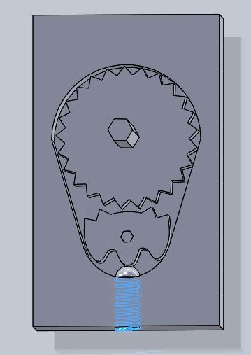This week Christian continued design of the ratchet system. The design utilizes sets of adjoining teeth to cause interference in one direction, but not the other. The design is shown in the figure below (Figure 1).

Figure 1 – Ratchet system design

1. As a group, we have been interviewing people on campus to see what they think about our handle and system design. Alexis interviewed a PhD student, who said that he liked our wider handle design. Cassie spoke with Professor Chang, who was generally excited about the system design, but pointed out a few potential weaknesses in the structural design. We will make sure to keep an eye on these when we do our FEA. I spoke with professor Dailey, who was concerned with the financial aspect of the project, and with design for sterilization. To account for this, we did some more research on sterilization, and we are now beginning to brainstorm how to design for easy sterilization. In general, feedback was positive, and we think that we have some interesting topics to consider.

**Next Steps**

1. We will be 3D printing a large version of the ratchet system to easily show functionality during the final presentation. We will do this using the printers at Lehigh. Upon finalization of handle design, we will also print one more set of handles.
2. Work will be done to integrate the ratchet system design with the handles.
3. A second finite element analysis will be done on the whole system. Points of interest for the second finite element analysis include joints, paddles, the scissor slider mechanism, and the ratchet system.
4. A dFMEA (Design Failure Mode Effects Analysis) will be conducted on the system to determine possible risk scenarios and to brainstorm ways to limit these.

**Question(s)**

1. Last semester you provided us with a financial estimate for production costs. We did have some design changes this semester, so we were wondering if we should change our cost estimates. Our bill of materials is included below in Figure 2 for your convenience.

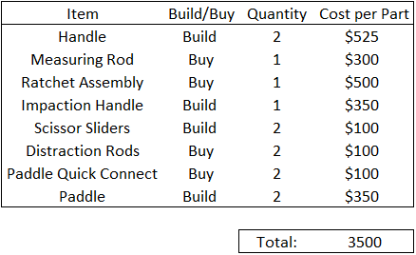

Figure 2 – Bill of materials